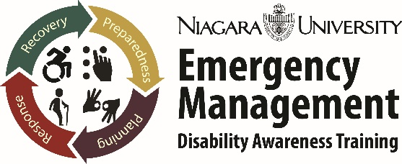
Niagara University Emergency Management Disability Awareness Training
Program Description and Details
Niagara University’s Disability Awareness Training program is proud to announce the debut of the Emergency Management Training series. The premise is to address the on-going challenges, misperceptions, inappropriate responses and lack of ADA compliance as it relates to individuals with disabilities and access and functional needs.
The program will provide emergency managers, personnel involved in emergency management, volunteers, disability advocates, individuals with disabilities and access and functional needs, and the those invested in proper response to the disability community the strategies, resources, tools, and guidance needed in planning, preparedness, response, and recovery.
Recognized by the New York State Independent Living Council, the New York Association on Independent Living, and the New York State Emergency Managers Association as the state’s training and education on this topic, Niagara University’s Disability Awareness Training program will be rolled out in the following manner:
- Emergency Management Disability Awareness Training; three-hour program that addresses what it entails to properly and accurately respond to individuals with disabilities and access and functional needs. Key aspects will include Inclusive planning and active participation that calls for the disability community to play a role in plan development, accessibility reviews of sites and shelters, outreach to disability-specific populations, resources and guidance. Those who should attend are emergency management personnel, Red Cross staff and volunteers, Department of Health, municipal employees who have any responsibility in emergency planning and preparedness, Firefighter administrators, disability advocates, parents of individuals with disabilities, developmental disability service providers, disability organizations, and those invested in the disability community. All attendees will be embedded in the tracking system and will be expected to input all activities they are involved in related to active participation in emergency management.

- Inclusive Planning and Active Participation (IPAP) Specialist; this two-day training is the full content on all aspects of planning, preparedness, response, and recovery. It will spell out what is involved in ensuring proper response, and will call for IPAP Specialists to play a key role in their municipality/county/region. Attendees will receive the working manual and flash drive that contains all the information necessary to guide emergency planning and preparedness. IPAP Specialists will have reporting responsibilities and will have a direct relationship with the NU DAT office. Individuals interested will need to apply and get accepted. Experience in disability advocacy and emergency planning will be a prerequisite. Personnel within municipalities who have a role in emergency planning and preparedness are also encouraged to apply.

- Emergency Management Offices (EMO) will be reviewed and critiqued on the premise of inclusive planning and active participation. Tracking of activity, starting with the Core Advisory Group, will be used as indicators. The intent is for EMOs to benefit from the knowledge, input, and efforts of individuals with disabilities and access and functional needs. Understanding the role they play, how to utilize their expertise, and embracing them as assets is mutually beneficial as they provide answers to questions and address matters as active participants. Ultimately, quality of life is preserved and lawsuits are avoided.

Reference the IPAP description, application, and training announcement for more details
Contact Information: Timon Hall, 105B PO Box 1941 Niagara University, NY 14109
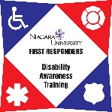
Phone: 716-286-7355
Website: frdat.niagara.edu; Email:frdat@niagara.edu

